
Aranmore Catholic College
Year 11 Human Biology
Pregnancy, Birth, Infancy, Childhood, Adolescence and Old Age

Section A: Multiple Choice 20 marks

- The state of pregnancy is also called
- parturition
- gestation
- lactation
- labour

- The term embryo is used to describe the developing human up until
- the 5th week
- the 8th week
- implantation
- segmentation

- Which statement is true?
- Where the unbiblical cord attaches to the chorion, the placenta develops
- The upper most layer of the embryo is the endoderm
- The embryonic disc separates the chorion cavity and the yolk sac
- The ectoderm will develop into the gut, trachea, lungs and liver.

- The breaking of water is caused by the
- rupturing of the chorion and the release of its fluid
- rupturing of the amnion and release of its fluid
- rupturing of the placenta and release of its fluid
- rupturing of the cervix and release of its fluid

- The diagram below shows the cervix almost completely opened and the amnion is bulging in the front of the head this is:
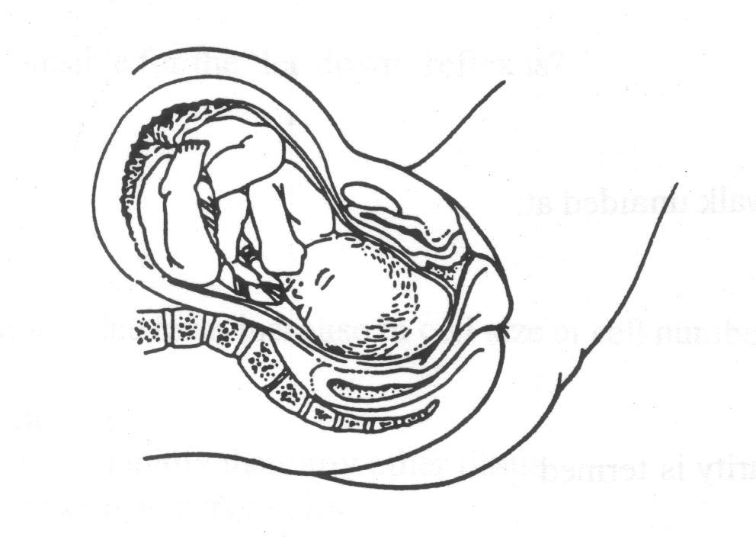

- early in the first stage of labour
- early in the second stage of labour
- late in the first stage of labour
- late in the second stage of labour

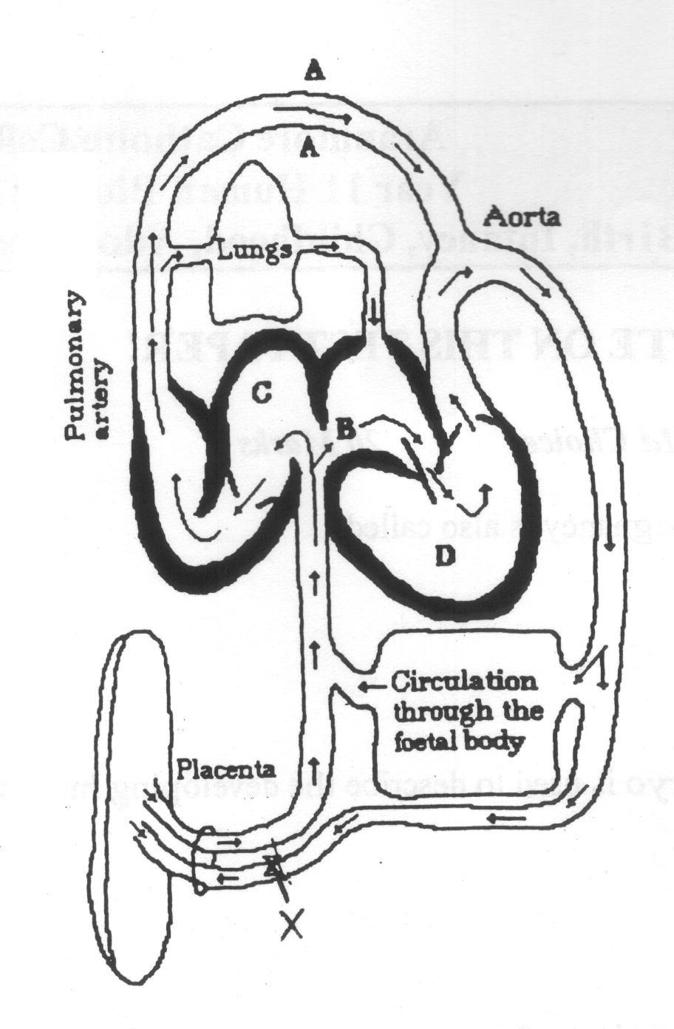
- Consider the following diagram:

Label A and X represent:
- ductus arteriosus and umbilical artery
- umbilical cord and umbilical artery
- umbilical cord and umbilical vein
- inferior vena cava and umbilical vein

- “As the date of the last menstruation can usually determine more accurately, than the date of conception, it is normally used to predict when birth will occur.” If the start of the last menstrual period was the 09/03/03. When can the women expect her child to be born?
- 14th December 2003
- 25th November 2003
- 9th December 2003
- 23rd December 2003

- Which of the following substances are received by the pregnant mother from the foetus?
- Urea and Carbon dioxide
- Carbon dioxide and glucose
- Urea and amino acids
- Amino acids and glucose

- The average child will begin to walk unaided at:
- 2 – 3 years
- 12 - 18 months
- 3 – 6 months
- 3 – 4 years

- The development of sexual maturity is termed
- adolescence
- puberty
- growing pains
- maturity

- The milk secreting regions of the breasts are called?
- lobes
- lobules
- alveoli
- areola
- The drawing below shows a male foetus, new born, boy and man.
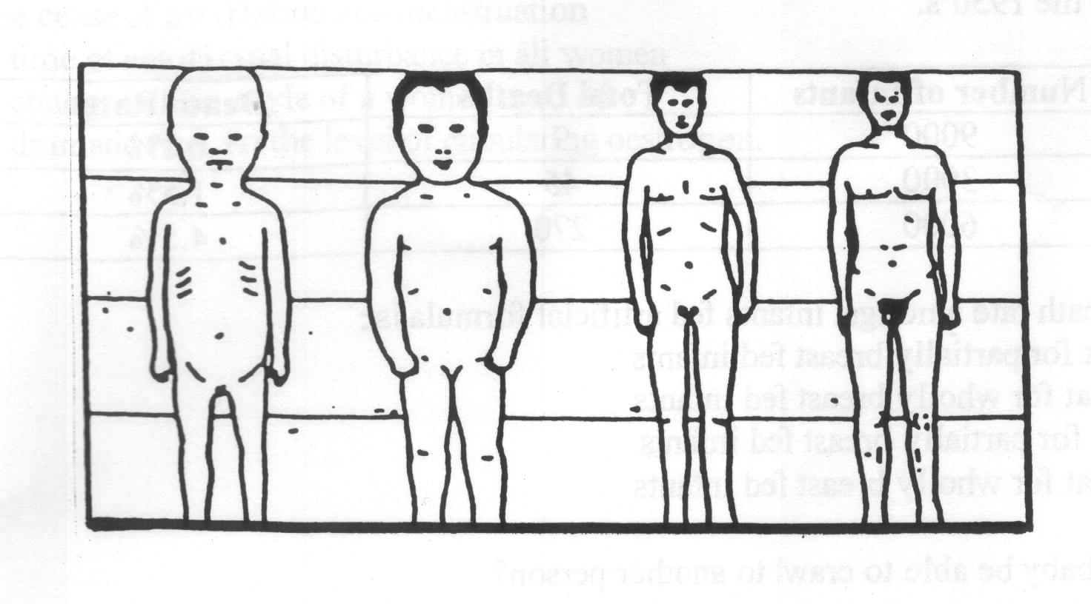

What is the best explanation of the changes shown in the diagram?
- The head becomes smaller
- Different parts of the body grow at different rates
- Men are stronger than babies
- The legs increase in length but the rest of the body does not.

- The term hospice refers to:
- a hospital for geriatric patients
- an old age home where individuals live, in which both emotional and physical needs are considered.
- a hospital for the terminally ill where medical facilities are specialised
- a hospital for terminally ill, in which both emotional and physical needs are considered

- The hormone responsible for the ‘let down’ reflex is?
- oxytocin
- progesterone
- prolactin
- oestrogen

- Growth of the brain is due to an increase in cell size or cell number, or both. At birth the brain is:
- increasing in cell number
- increasing in size more rapidly than any other tissue
- no longer able to make new nerve cells
- no longer able to grow

- At what stage should a baby be able to crawl to another person?
- 1 – 3 months
- 4 – 5 months
- 6 – 9 months
- 10-12 months

- The act of maintaining and delivery of milk to the newborn is termed:
- Milking
- lactation
- colostrum
- feeding

18. The term menopause refers to:
- the cease of ovulation and menstruation
- a time of emotional disturbance in all women
- a change in life style of a women aged 45
- a dramatic rise in the level of circulating oestrogen.

- The following table shows Deaths during infancy (first 9 months) related to types of feeding in third world countries in the 1950’s.

Food | Number of infants | Total Deaths | Death Rates
Wholly breast fed | 9000 | 9 | 0.1%
Partially breast fed | 3000 | 45 | 1.5%
Fed artificially formula | 6000 | 270 | 4.5%

From the table above the death rate amongst infants fed artificial formula is:
- 6 times greater than that for partially breast fed infants
- 30 times greater than that for wholly breast fed infants
- 4 times greater that that for partially breast fed infants
- 45 times greater than that for wholly breast fed infants

- From the data below, which of the following statements can be induced?
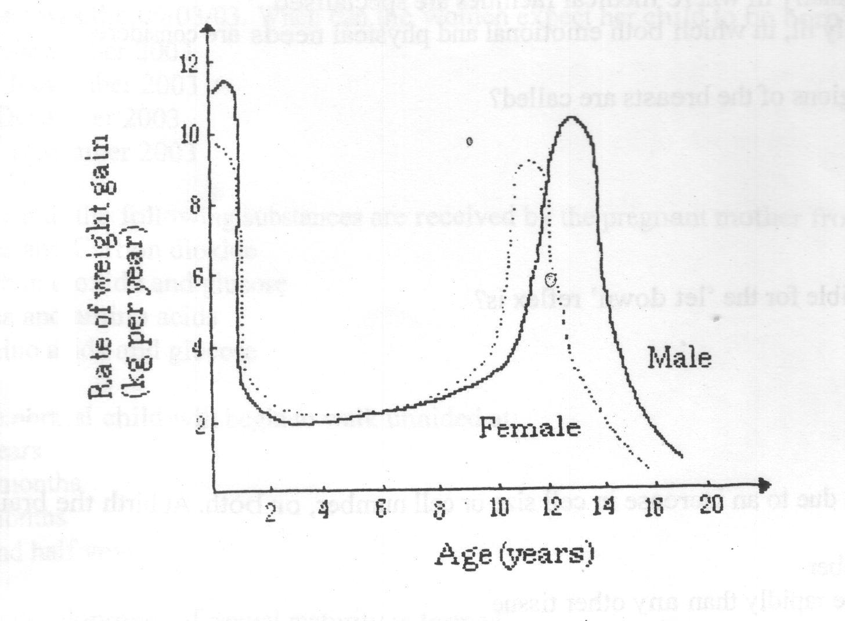

- All boys have their greatest period of adolescent growth later than girls
- Some boys have their greatest period of adolescent growth earlier than girls
- During adolescence the average boy achieves greatest weight gain later than the average girl
- From the age of 14 onwards most boys and girls lose weight.

Section B: Short Answers 31 Marks

- What secondary sexual characteristics would a physical maturity adolescent present? List for both males and females.
(5 marks)
_________________________________________________________________________________________________________________________________________________________________________________________________________________________________________________________________________________________________________________________________________________________

- Comment on how an infant can be feed, give two advantages and two disadvantages of your chosen method of feeding.
(4 marks)
_________________________________________________________________________________________________________________________________________________________________________________________________________________________________________________________________________________________________________________________________________________________

- Describe the position of the baby;
- during a normal delivery
- during a breech delivery
(2 marks)
_________________________________________________________________________________________________________________________________________________________________________________________________________________________________________________________________________________________________________________________________________________________

- What are the three primary germ layers of embryonic tissue and name two features, which develop from each.
(6 marks)

_________________________________________________________________________________________________________________________________________________________________________________________________________________________________________________________________________________________________________________________________________________________

- Refer to the graph below
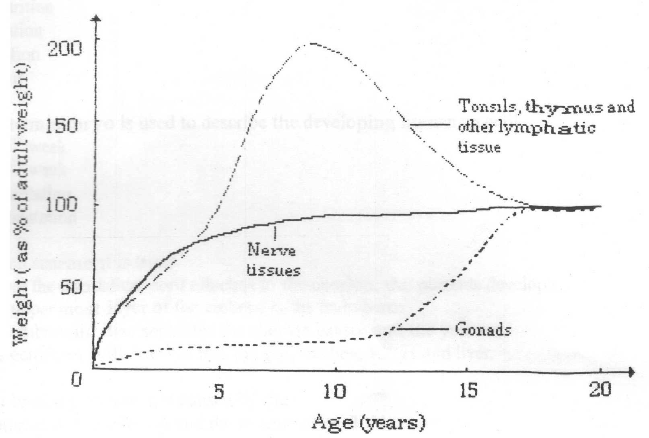

- From the graph estimate what percentage of the total size is the brain of a 5 year old?
________________________________________________________

- From the graph estimate what percentage of the total size are the reproductive organs of a 5 year old.
________________________________________________________

- From the graph estimate what percentage of the total size are the tonsils, thymus and other lymphatic tissue of a 5 year old.
________________________________________________________

- What are the advantages of the relatively late development of the reproductive organs?
________________________________________________________

(4 marks)

- The table below shows the volume of oxygen transported to and from the foetus during the final week of pregnancy.

Blood Vessel | Volume of Oxygen transported (ml/g/minute)
Umbilical Artery | 3.09
Umbilical Vein | 4.81

(a) Using the above data, calculate the rate of oxygen uptake per gram of a foetus with a mass of 3.3kg. Show all working.
(2 marks)
______________________________________________________________________________________________________________________________________________________________________________________________________

(b) In the final week of pregnancy the placenta stops growing. Suggest why the tissues of the placenta still have a high rate of oxygen uptake.
(2 marks)
______________________________________________________________________________________________________________________________________________________________________________________________________
(c) During pregnancy, the mother experiences many changes to her body that increases her oxygen consumption. Describe THREE (3) significant physiological changes in her body that cause an increase in oxygen consumption.
(6 marks)
__________________________________________________________________________________________________________________________________________________________________________________________________________________________________________________________________________________________________________________________________________

Answer Sheet

- B
- B
- A
- B
- C
- A
- A
- A
- B
- B
- A
- B
- D
- A
- B
- C
- B
- A
- B
- C

